Self-collected Throat Swab Instructions

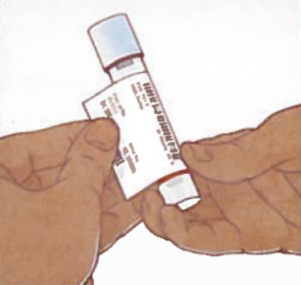
- Wash your hands with soap and water.
- Remove the transport tube and collection swab from packaging.
- Label the transport tube with your patient label.
- Label the transport tube with the throat label.
- Open the package containing the collection swab, labeled with green writing. The collection swab is blue.
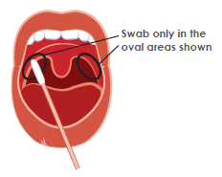
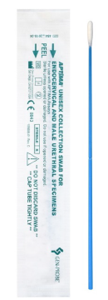
- Hold the collection swab far enough from the tip.
- Say AHH…and reach the collection swab into your mouth to gently touch your throat.
- Gently rub the swab tip on your throat, side to side, up and down at least 5 times.
- Unscrew the cap from the transport tube.

Important! Do not pour out the liquid in the tube. Do not puncture the foil on the cap top.

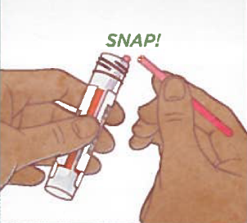
- Place the collection swab into the transport tube, snapping it at dashed line.
- Put the cap back on the transport tube and twist it closed to prevent leaks.
- Put the transport tube into the transparent bag.
- Wash your hands with soap and water.

