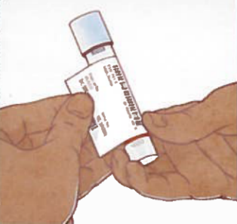
Self-collected Rectal Swab Instructions
- Wash your hands with soap and water.
- Remove the transport tube and collection swab from packaging.
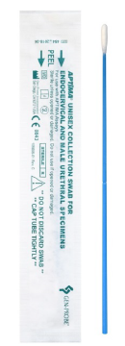
- Label the transport tube with your patient label.
- Label the transport tube with the rectal label.
- Open the package containing the collection swab, labeled with green writing. The collection swab is blue.
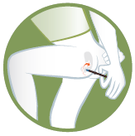
- Firmly hold the collection swab above the dashed line (closer to the swab tip).
- Get into a comfortable position that allows you access to your anus. Putting your foot on the step stool may help.
- Gently insert the swab 1 inch into the rectum and twirl the swab in a circle at least 5 times.
- Unscrew the cap from the transport tube.
Important! Do not pour out the liquid in the tube. Do not puncture the foil on the cap top.
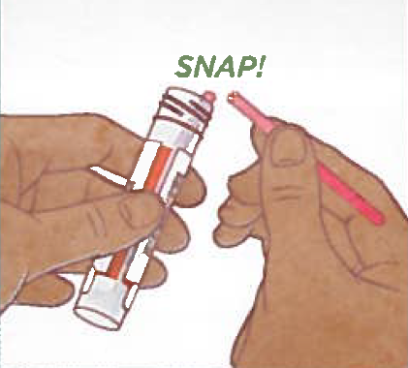
- Place the collection swab into the transport tube, snapping it at dashed line.
- Put the cap back on the transport tube and twist it closed to prevent leaks.
- Put the transport tube into the transparent bag.
- Wash your hands with soap and water.

